Kevin Valenzuela

November 2018

Digital Image Processing

Face Recognition

The goal of this project was to use Principal Component Analysis (PCA) for face recognition. I was provided with test images and had to include test images of my own face for this project. The first step I took was to get my dataset ready. I chose to have the first ten people, including myself for the enrollment of the images. This means that I had a total of 50 pictures for my enrollment. These pictures were converted from matrices to vectors for processing. Below is a sample of that enrolling images I used.

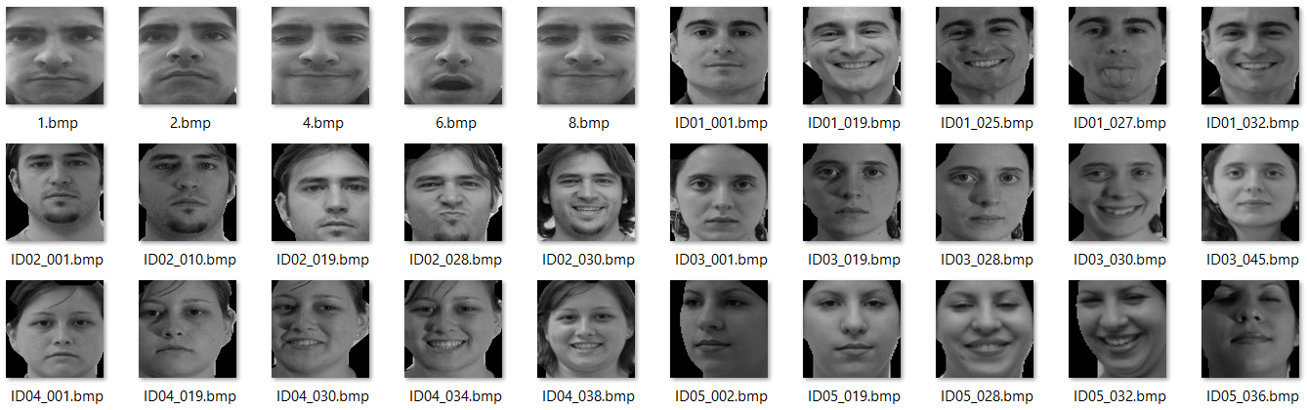

Once the images are imported then I continued to create eigenfaces. This is the point where I add up all the images and divide by the number of images I must get the average. This average will be subtracted from every image and what is left is what is unique to the face. At this point I have my eigenfaces. Below is a screenshot. The first screenshot is without converting the images to uint8, and the second one is a lot darker because of this conversion.

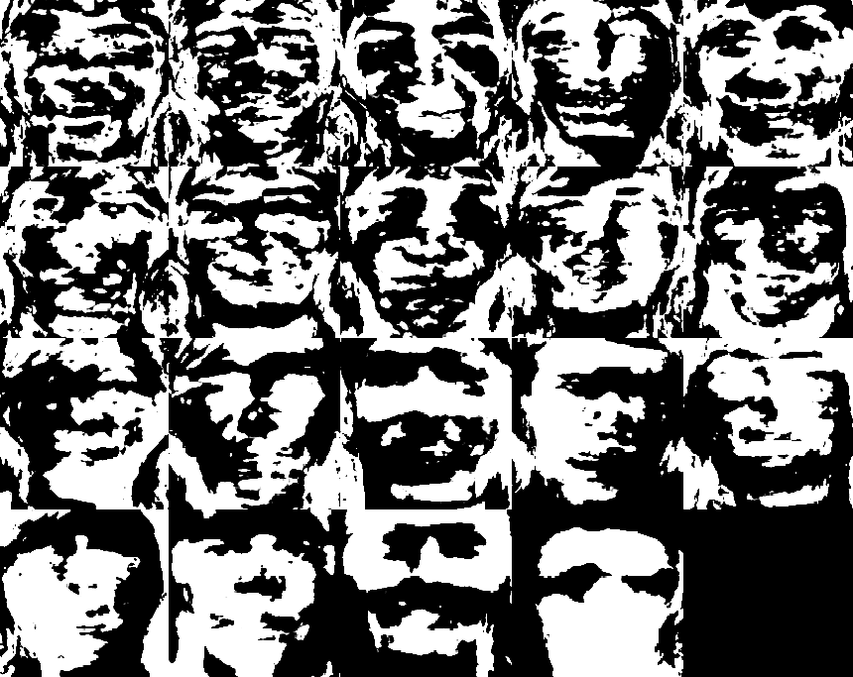

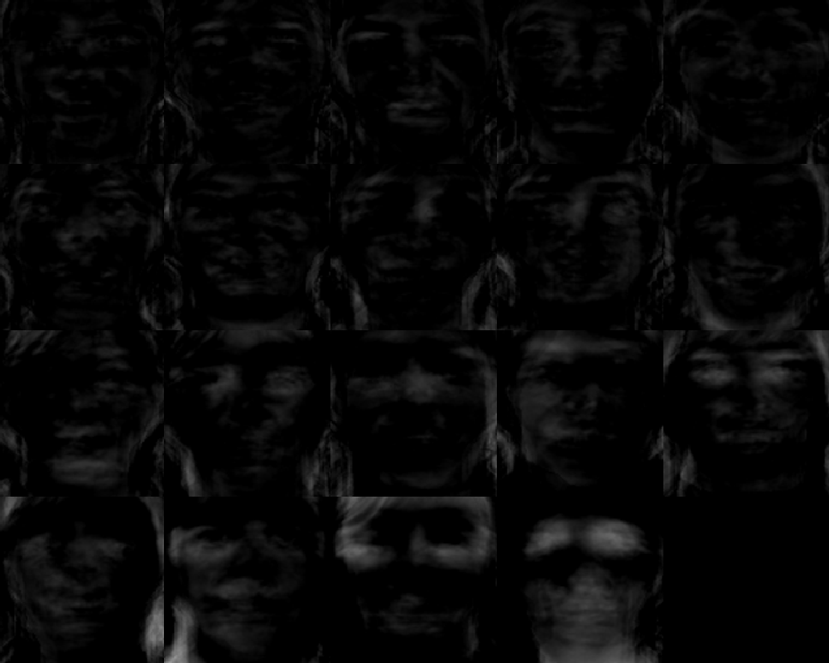

These eigenfaces have a ‘ghostly’ feature to them. I’m not entirely sure why the last one is just a solid black image. Below I will graph the weight of the first person in the dataset, which is myself.

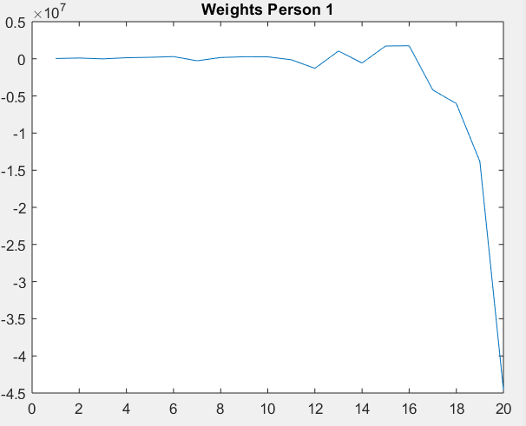

The image below shows my CMC curve. It looks like it hit the max point and stayed at 30% for the remainder of the time.

